Logo de votre école (ne garder que le bon logo)
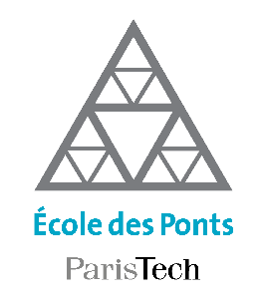

Research Topic for the ParisTech/CSC PhD Program
(one page maximum)

Field: Choisissez un élément.

Subfield: (Applied Physics, Chemistry, Mathematics, Mech. Eng.…)

Title:

ParisTech School: Choisissez un élément.

Advisor(s) Name:
Advisor(s) Email:
Research group/Lab:
Lab location:
(Lab/Advisor website):

Short description of possible research topics for a PhD: (10-15 lines in English + optional figure)

Required background of the student: (Which should be the main field of study of the applicant before applying)

A list of 5 (max.) representative publications of the group: (Related to the research topic)

